**HandsOn :9**

**Code:**

//IndianPlayer.jsx

import React from 'react';

const IndianPlayers = () => {

  const T20players = ['Virat', 'Rohit', 'Hardik', 'Pant'];

  const RanjiTrophy = ['Jaiswal', 'Shaw', 'Sarfaraz', 'Iyer'];

  const allPlayers = [...T20players, ...RanjiTrophy];

  const oddTeam = allPlayers.filter((_, i) => i % 2 === 0);

  const evenTeam = allPlayers.filter((_, i) => i % 2 !== 0);

  return (

    <div>

      <h2>All Indian Players</h2>

      <p>Merged Players: {allPlayers.join(', ')}</p>

      <h3>Odd Team</h3>

      <ul>

        {oddTeam.map((player, index) => <li key={index}>{player}</li>)}

      </ul>

      <h3>Even Team</h3>

      <ul>

        {evenTeam.map((player, index) => <li key={index}>{player}</li>)}

      </ul>

    </div>

  );

};

export default IndianPlayers;

//List of plaayers.jsx

import React from 'react';

const ListofPlayers = () => {

  const players = [

    { name: 'Virat', score: 95 },

    { name: 'Rohit', score: 80 },

    { name: 'Rahul', score: 45 },

    { name: 'Jadeja', score: 70 },

    { name: 'Bumrah', score: 65 },

    { name: 'Shami', score: 88 },

    { name: 'Gill', score: 92 },

    { name: 'Pant', score: 56 },

    { name: 'Hardik', score: 76 },

    { name: 'Surya', score: 69 },

    { name: 'Kuldeep', score: 85 }

  ];

  const below70 = players.filter(player => player.score < 70);

  return (

    <div>

      <h2>All Players</h2>

      <ul>

        {players.map((player, index) => (

          <li key={index}>{player.name} - {player.score}</li>

        ))}

      </ul>

      <h3>Players with Score below 70</h3>

      <ul>

        {below70.map((player, index) => (

          <li key={index}>{player.name} - {player.score}</li>

        ))}

      </ul>

    </div>

  );

};

export default ListofPlayers;

For Flag=True;

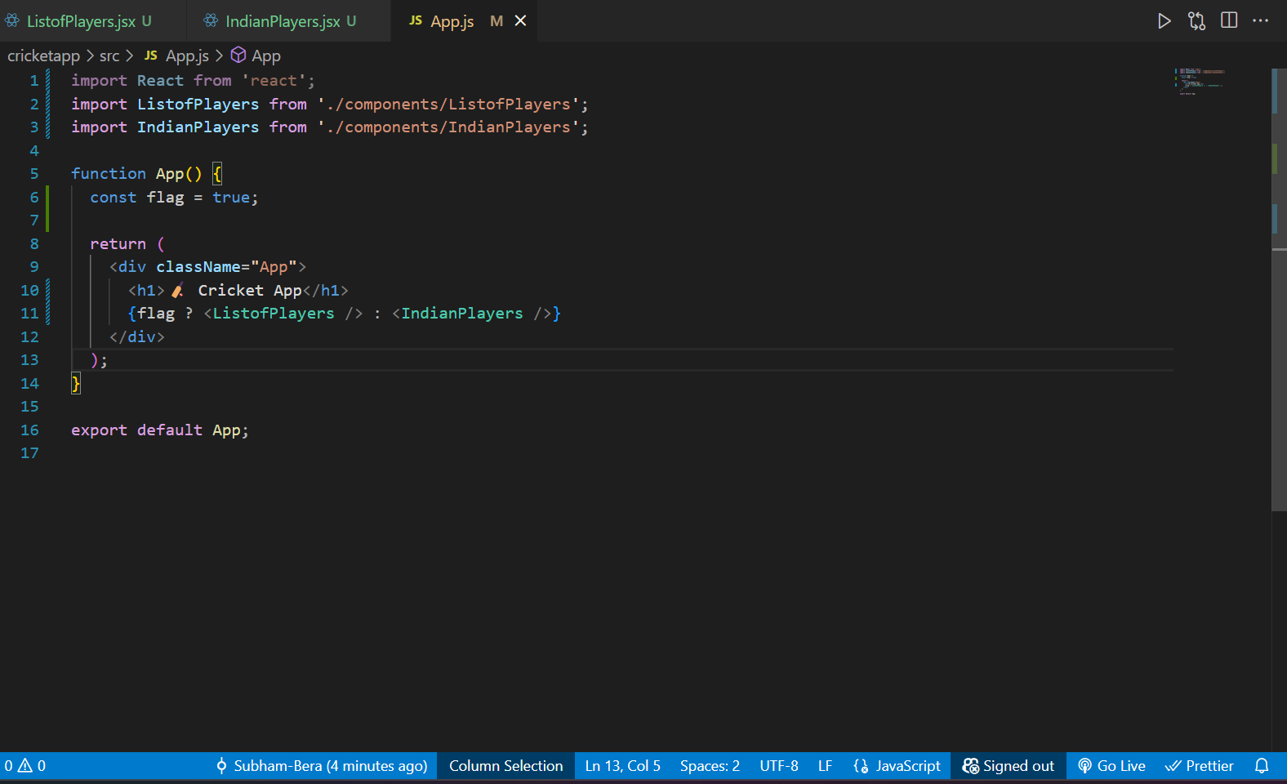

**OUTPUT:**

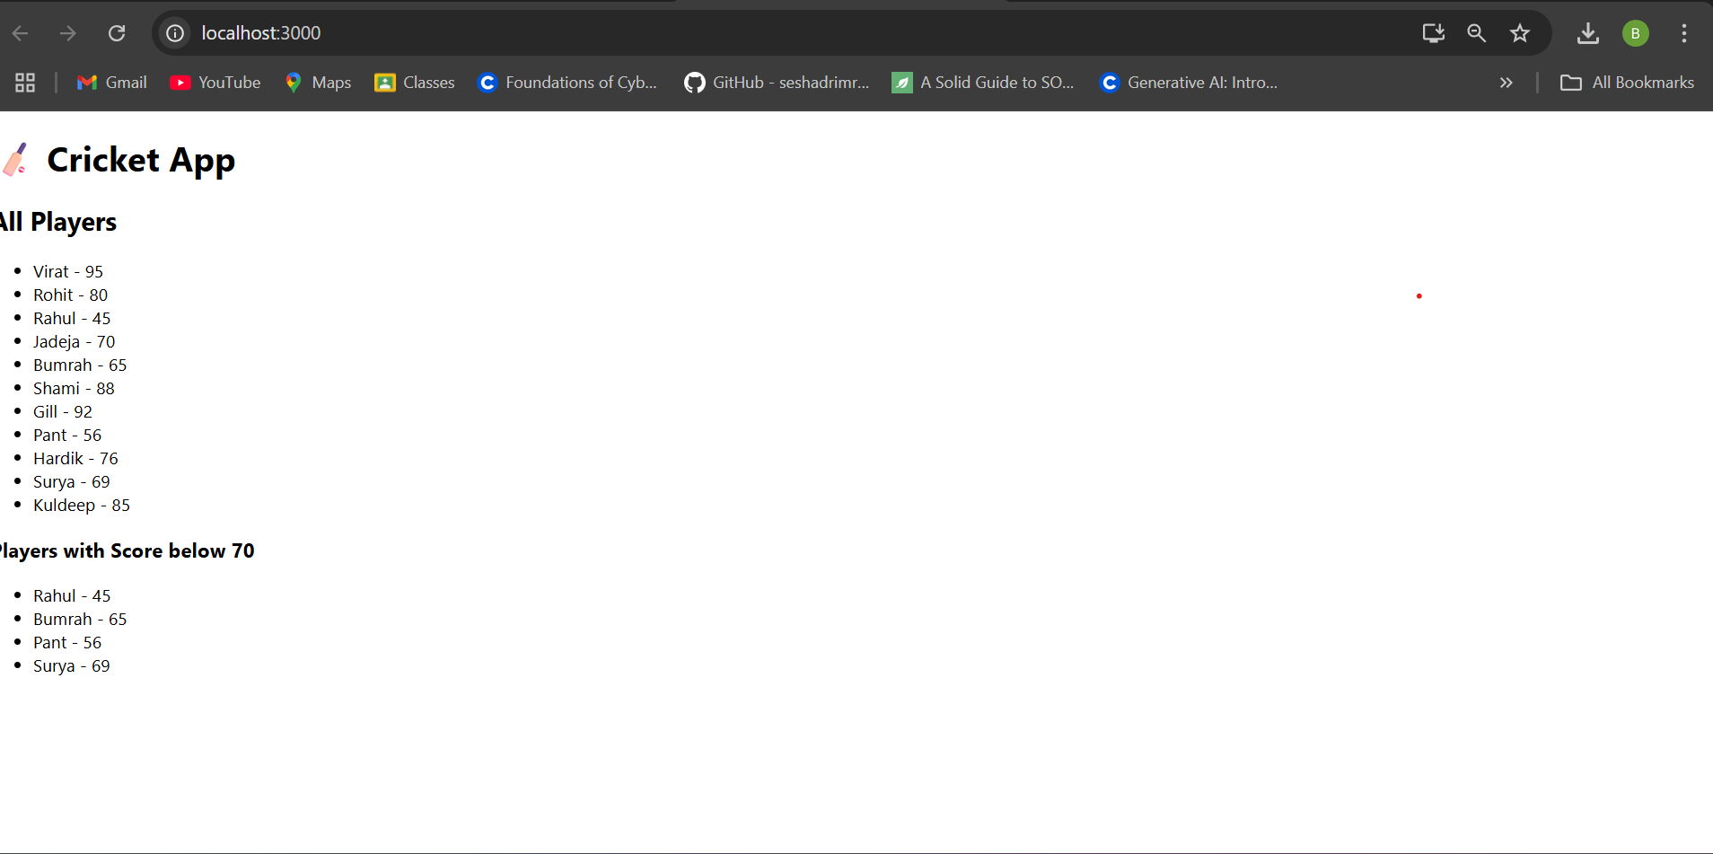

For flag=False;

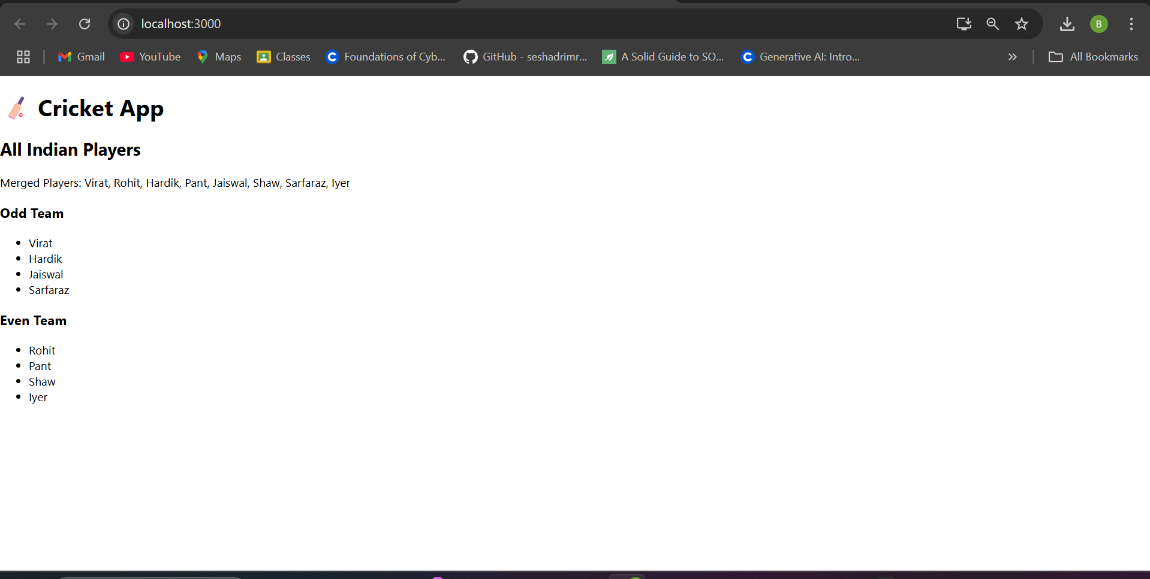

**HandsOn 10:-**

**Code:**

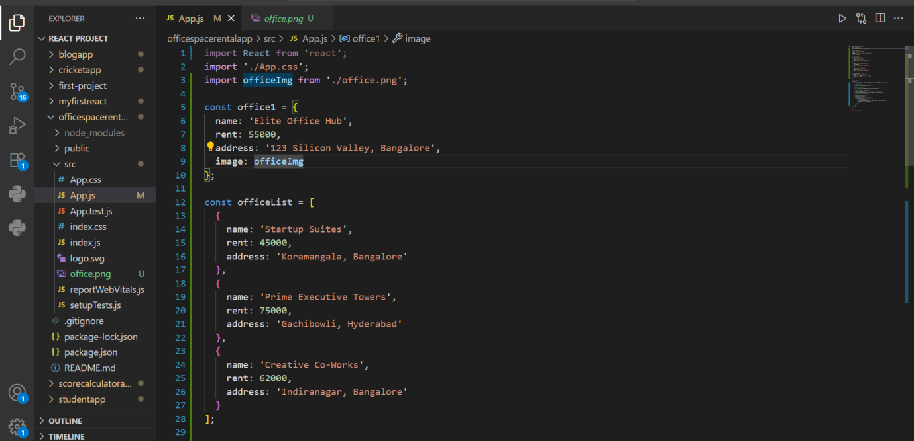

**OUTPUT:**

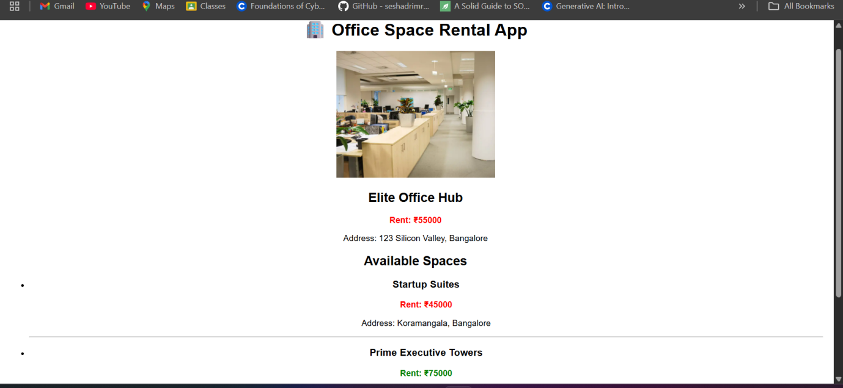

**HandsOn :- 11**

**Code:**

**APP.JS**

import React, { Component } from 'react';

import CurrencyConvertor from './CurrencyConvertor';

class App extends Component {

  constructor(props) {

    super(props);

    this.state = {

      count: 0,

      message: ''

    };

  }

  increment = () => {

    this.setState({ count: this.state.count + 1 }, () => {

      this.sayHello();

    });

  };

  decrement = () => {

    this.setState({ count: this.state.count - 1 });

  };

  sayHello = () => {

    this.setState({ message: 'Hello! This is a static message.' });

  };

  sayWelcome = (msg) => {

    alert(`Welcome message: ${msg}`);

  };

  handleClick = (event) => {

    alert('I was clicked');

    console.log(event);

  };

  render() {

    return (

      <div style={{ padding: '20px', fontFamily: 'Arial' }}>

        <h1>🎯 React Event Handling Lab</h1>

        <h2>Counter: {this.state.count}</h2>

        <button onClick={this.increment}>Increment</button>{' '}

        <button onClick={this.decrement}>Decrement</button>

        <p>{this.state.message}</p>

        <hr />

        <button onClick={() => this.sayWelcome('Welcome to React!')}>

          Say Welcome

        </button>

        <hr />

        <button onClick={this.handleClick}>OnPress Event</button>

        <hr />

        <CurrencyConvertor />

      </div>

    );

  }

}

export default App;

**CurrencyConverter.jsx**

import React, { Component } from 'react';

class CurrencyConvertor extends Component {

  constructor(props) {

    super(props);

    this.state = {

      rupees: '',

      euro: ''

    };

  }

  handleChange = (e) => {

    this.setState({ rupees: e.target.value });

  };

  handleSubmit = () => {

    const euroValue = (parseFloat(this.state.rupees) / 89).toFixed(2); // example rate

    this.setState({ euro: euroValue });

  };

  render() {

    return (

      <div>

        <h2>💱 Currency Convertor</h2>

        <label>Enter amount in INR: </label>

        <input

          type="number"

          value={this.state.rupees}

          onChange={this.handleChange}

        />

        <button onClick={this.handleSubmit}>Convert</button>

        {this.state.euro && (

          <p>💶 Value in Euros: €{this.state.euro}</p>

        )}

      </div>

    );

  }

}

export default CurrencyConvertor;

**OUTPUT:**

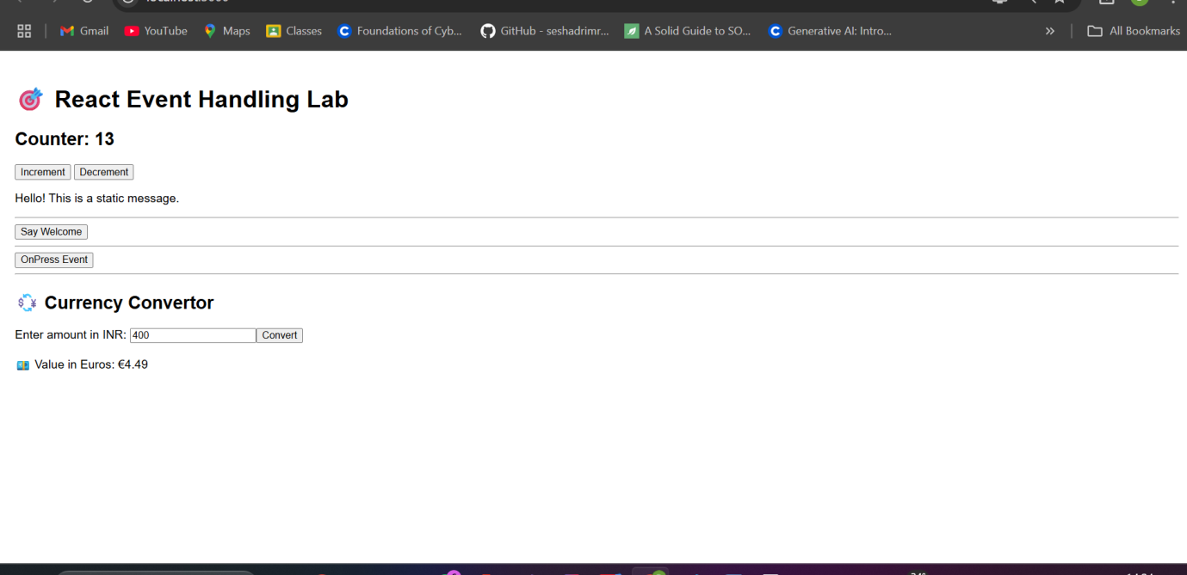

**HANDS ON 12:-**

**Code:**

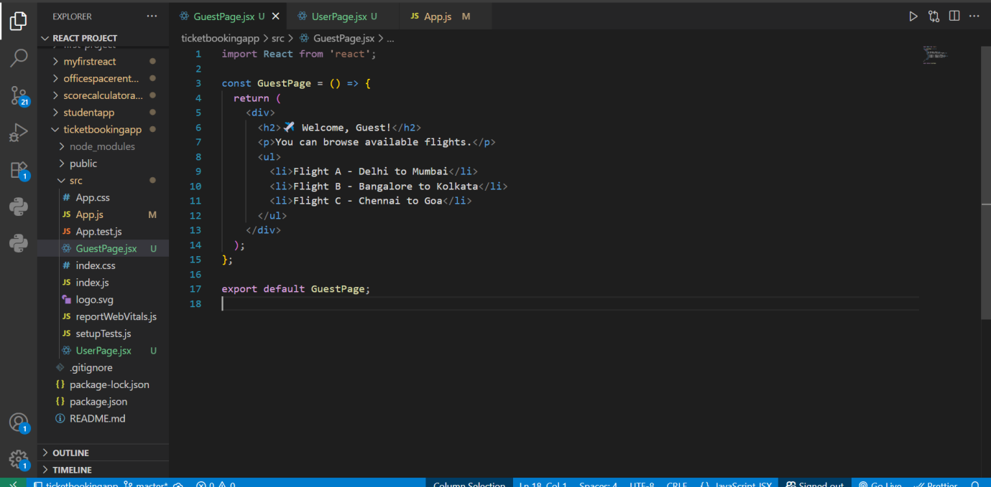

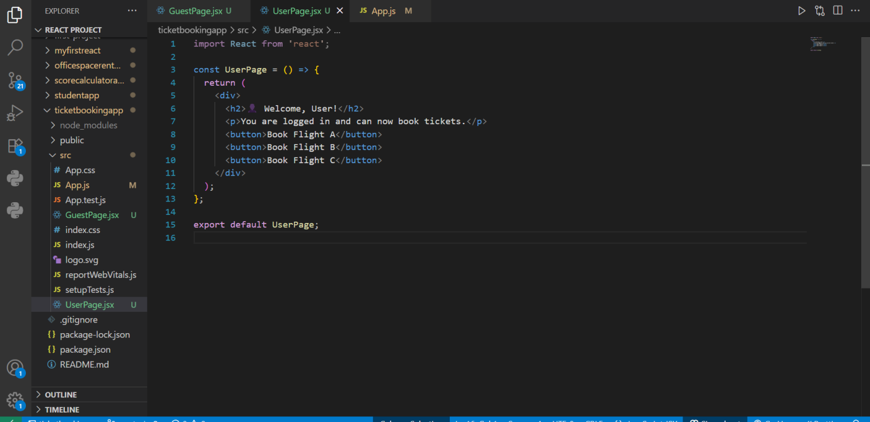

**App.js**

import React, { useState } from 'react';

import GuestPage from './GuestPage';

import UserPage from './UserPage';

function App() {

  const [isLoggedIn, setIsLoggedIn] = useState(false);

  const handleLogin = () => setIsLoggedIn(true);

  const handleLogout = () => setIsLoggedIn(false);

  let displayPage;

  if (isLoggedIn) {

    displayPage = <UserPage />;

  } else {

    displayPage = <GuestPage />;

  }

  return (

    <div className="App" style={{ padding: '20px', fontFamily: 'Arial' }}>

      <h1>🛫 Ticket Booking App</h1>

      {!isLoggedIn ? (

        <button onClick={handleLogin}>Login</button>

      ) : (

        <button onClick={handleLogout}>Logout</button>

      )}

      <hr />

      {displayPage}

    </div>

  );

}

export default App;

**OUTPUT:**

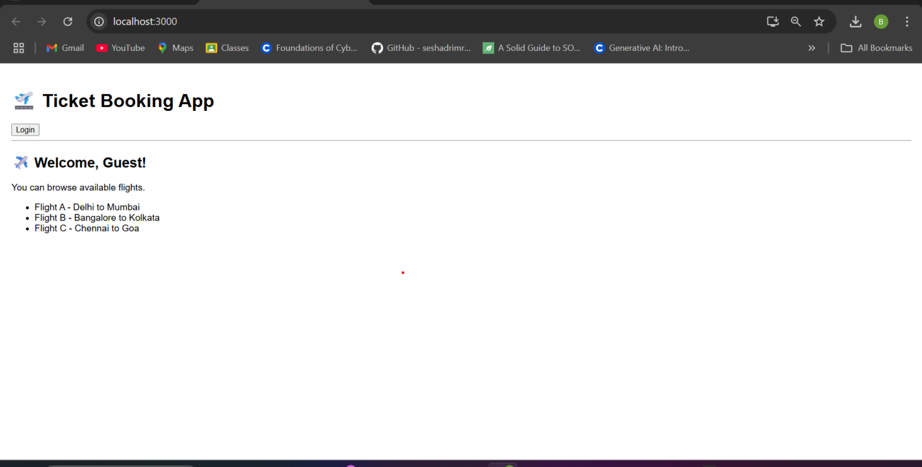

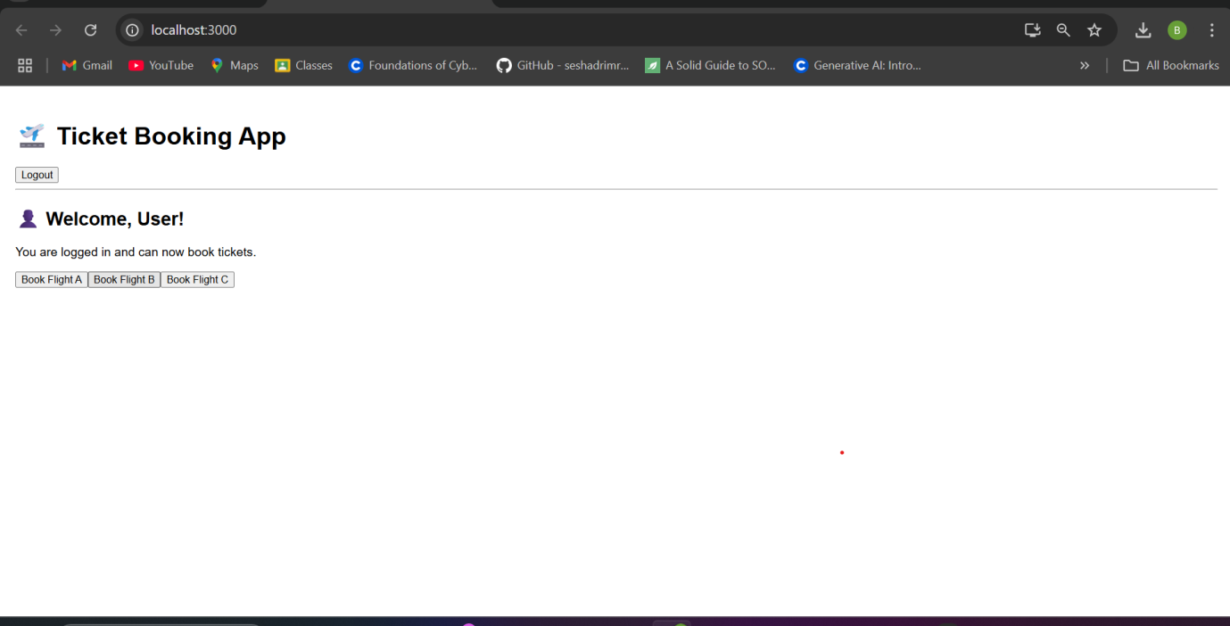

**HANDS ON 13:-**

**Code:**

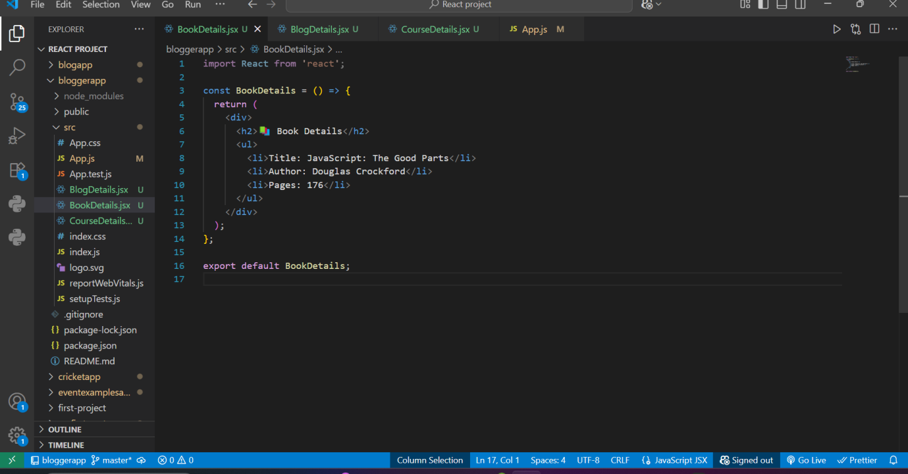

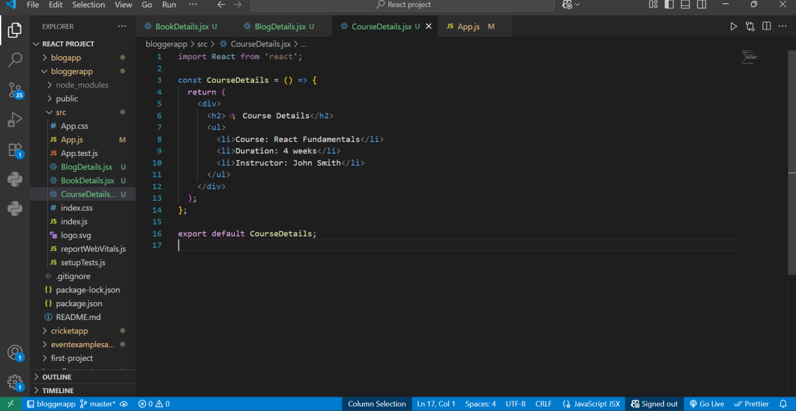

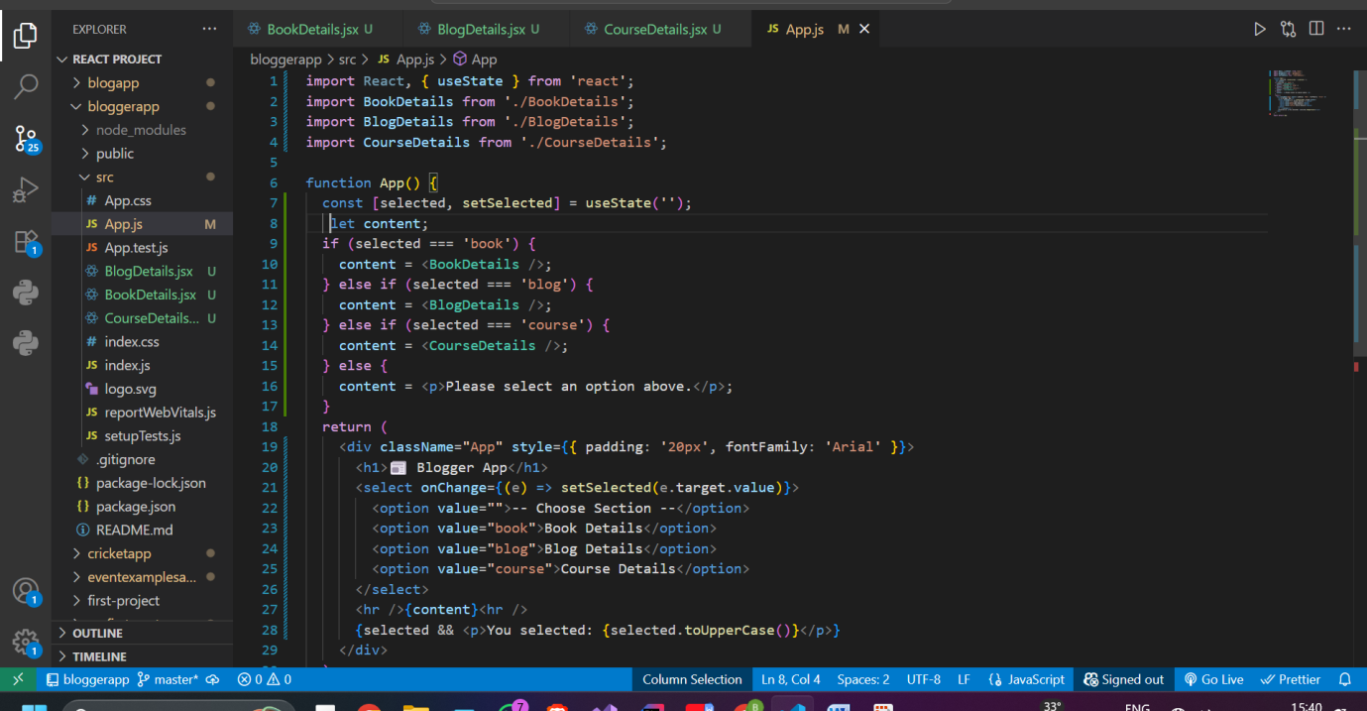

**OUTPUT:** 